Practical - 1
Practical Title: Project Initiation, Requirement Analysis, Sitemap, Wireframe, and GitHub Setup

Problem Definition: Initiate the semester-long StudentHub portal by identifying the problem scope, user roles, key modules, navigation flow, and minimum 10 pages. Create a sitemap, low-fidelity wireframe, project folder structure, README file, and GitHub repository.

Theory

1. What is URL and parts of URL?
Answer: A URL (Uniform Resource Locator) is the address used to locate a resource on the internet. It has five main parts - Scheme/Protocol (http:// or https://) which tells the browser how to talk to the server, Domain name (www.studenthub.com).

2. How does HTML file process in web browser?
Answer: When a page is requested, the browser sends an HTTP request and the server sends back the HTML as plain text. The browser's HTML parser reads it top to bottom and builds a DOM (Document Object Model) tree from the tags.

3. How will page navigation flow managed among all HTML pages?
Answer: Navigation is managed by linking pages with anchor tags using relative paths, e.g. <a href="dashboard.html">Dashboard</a>. One common navbar is reused across all 10 pages (Home, About, Register, Login, Dashboard, about, Profile, annouancement, fees,feedback .

4. How will GitHub commits be maintained after each practical?
Answer: One GitHub repository was created for the whole StudentHub project in this practical. After finishing each practical, changed files are staged with git add, committed with a clear message describing the work (e.g. "Practical 2: Added semantic HTML5 structure for all pages"), and pushed with git push. This keeps roughly one commit per practical, so the commit history becomes a timeline of the project's progress, which is also useful during the viva.

Implementation/ Output/Result

The StudentHub portal was planned with 10 pages - Home, About, Register, Login, Dashboard, announacment, feedback, fees, and attendance. A sitemap was made showing public pages (open to everyone) and role-based pages (Dashboard/Admin, visible only after login). A low-fidelity wireframe was sketched for each page layout. The project folder structure and README.md were created and pushed to a new GitHub repository.

Evidence of Work (Screenshots)

Sitemap :
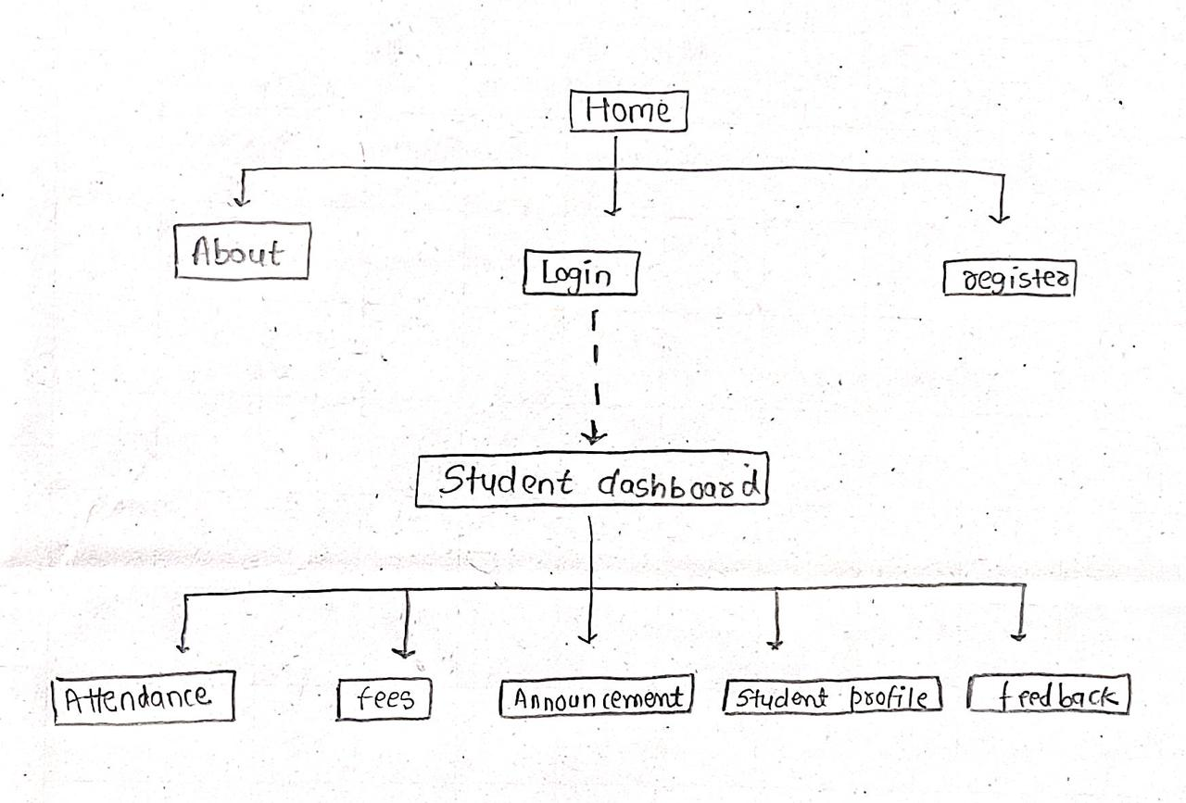

Description:
The sitemap shows StudentHub's page hierarchy. Home is the entry point, linking to About and Register (public pages) and Login.

Home page :
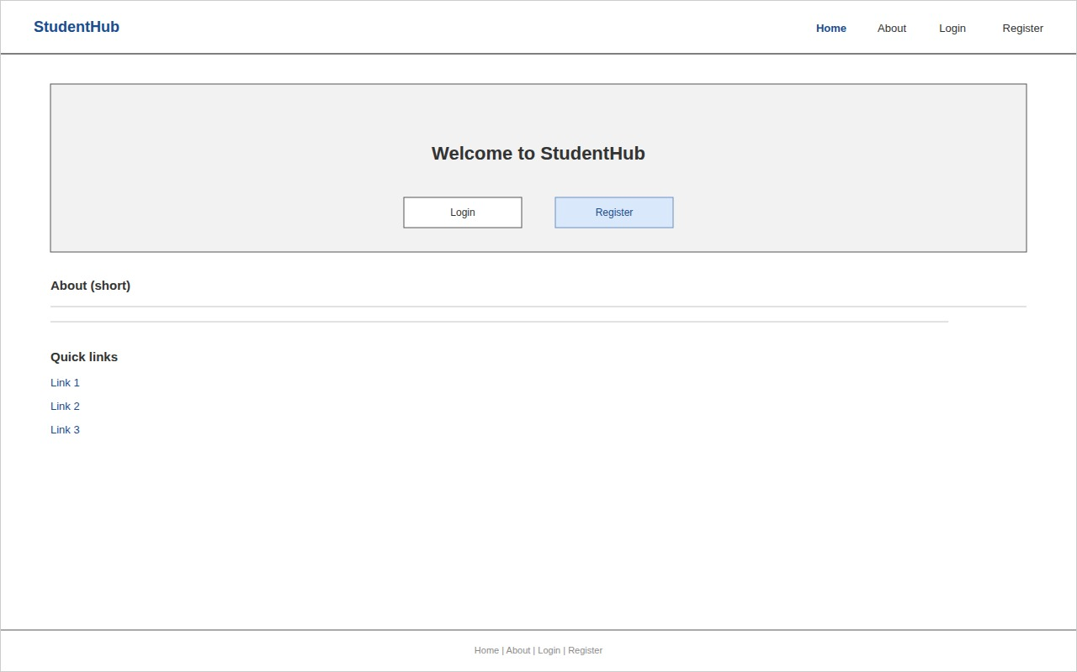

Login page :
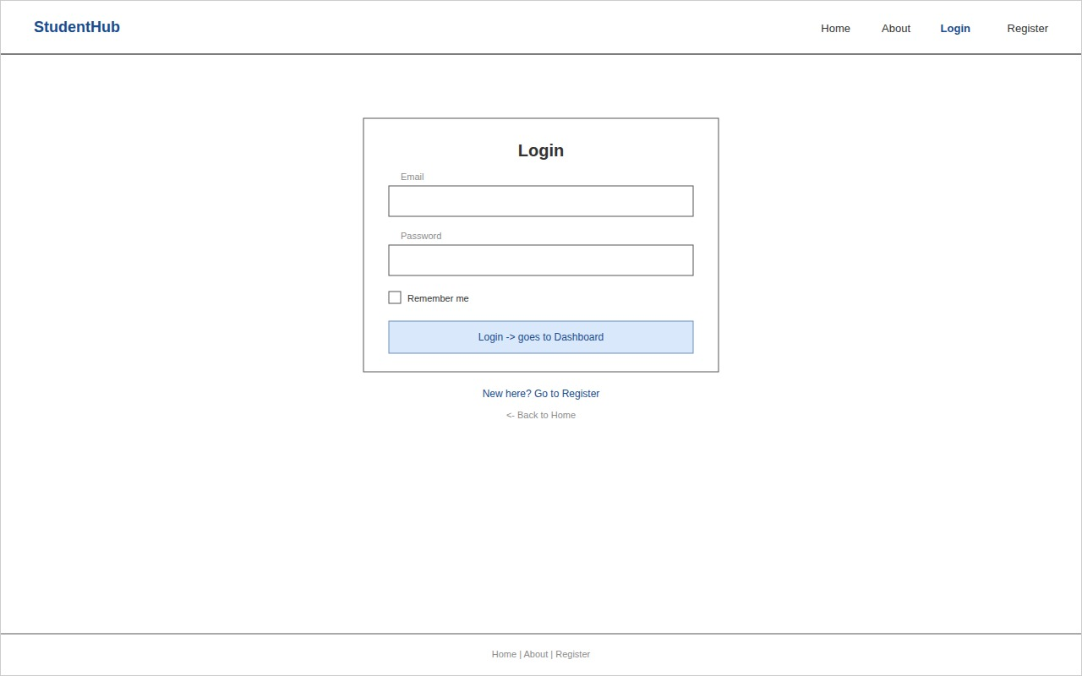
Register page :
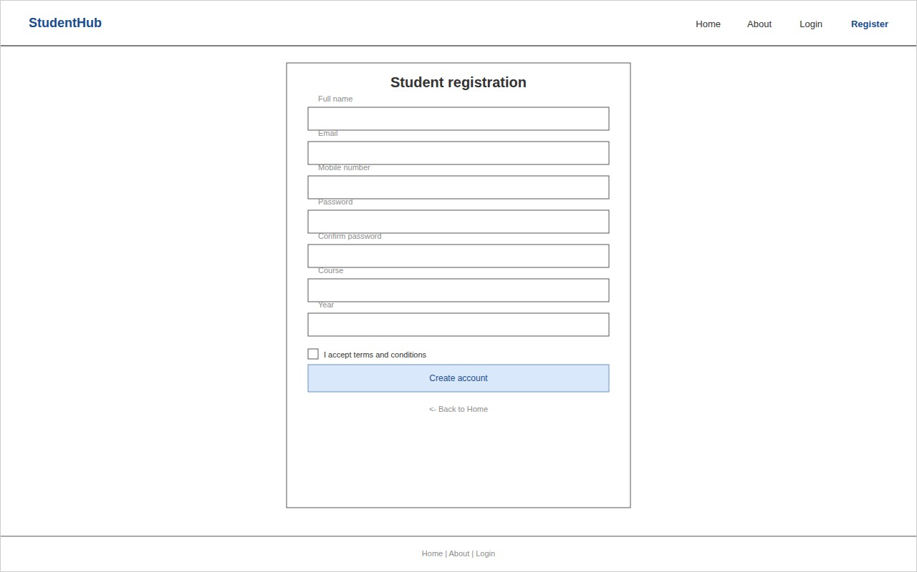

About page :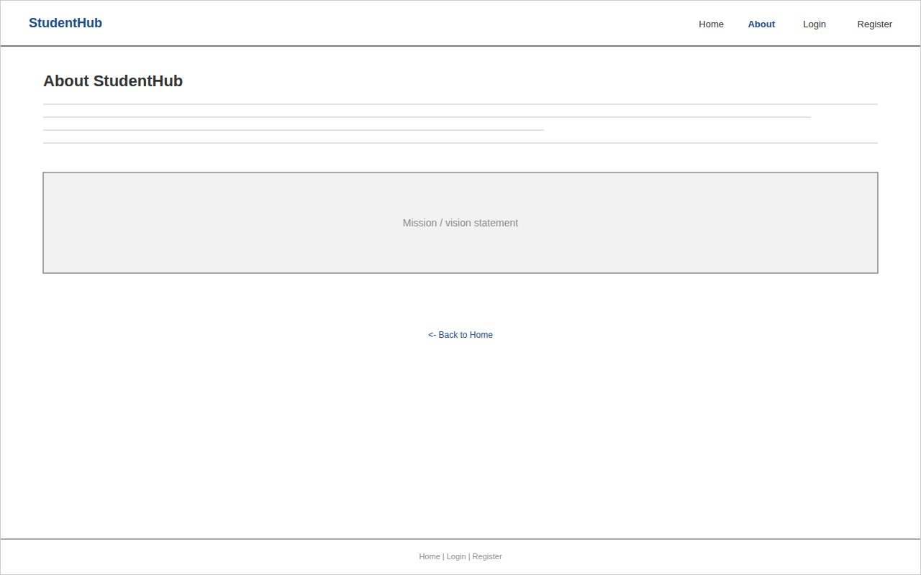
Dashboard page :
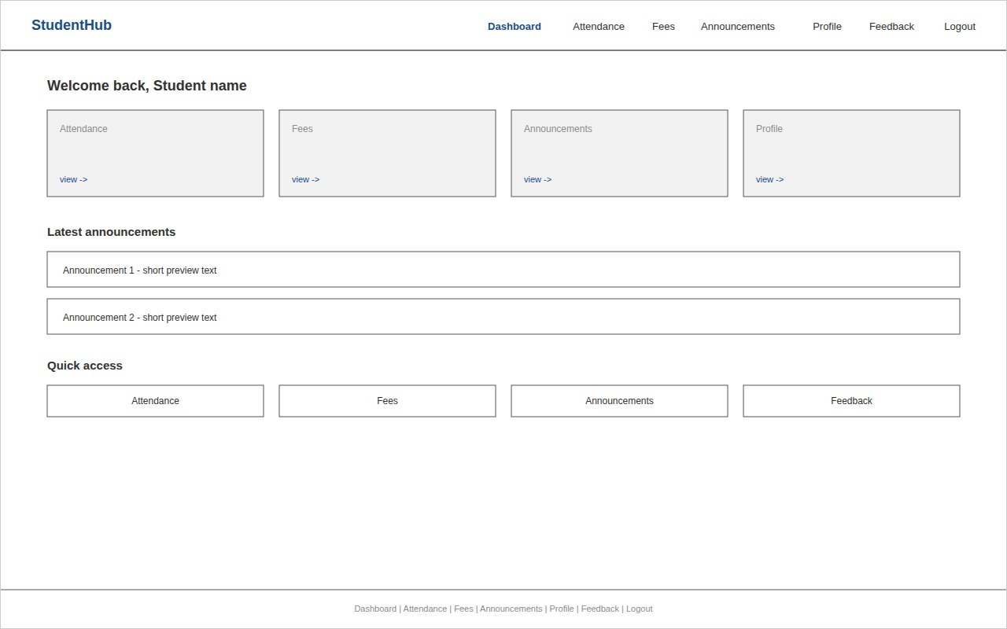

Attendance page :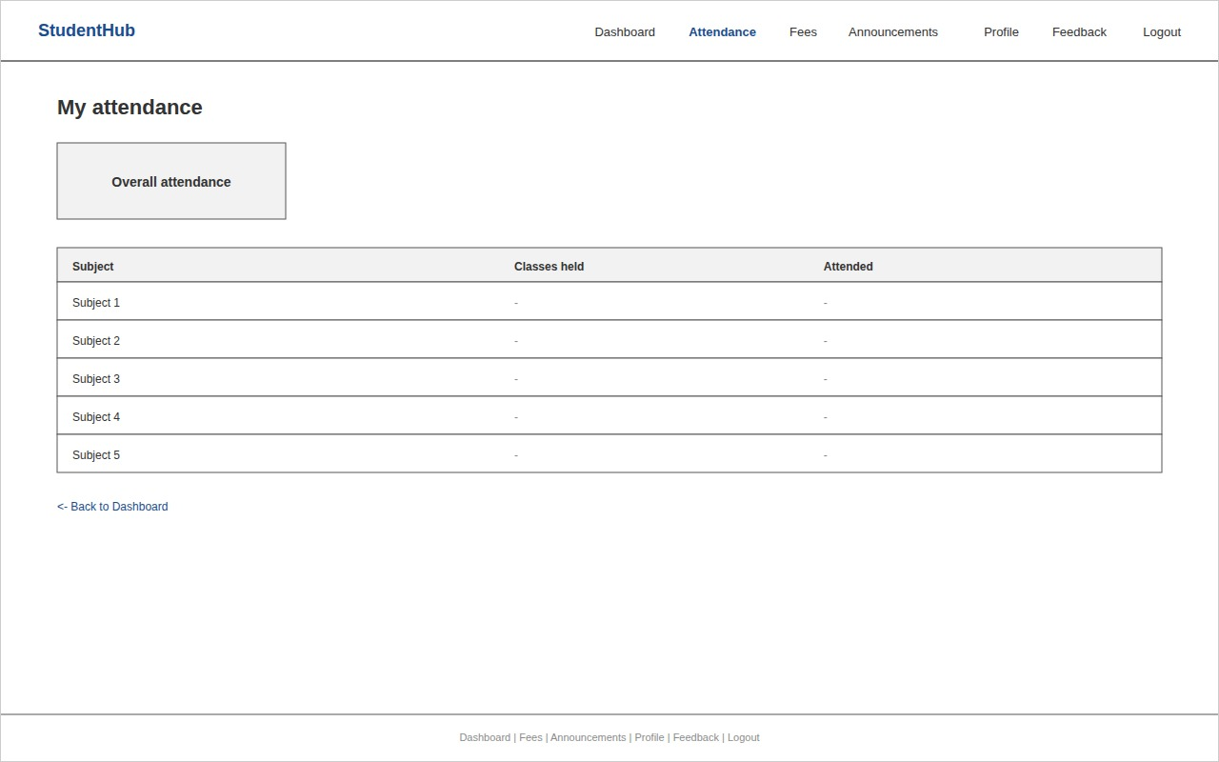
Fees page :
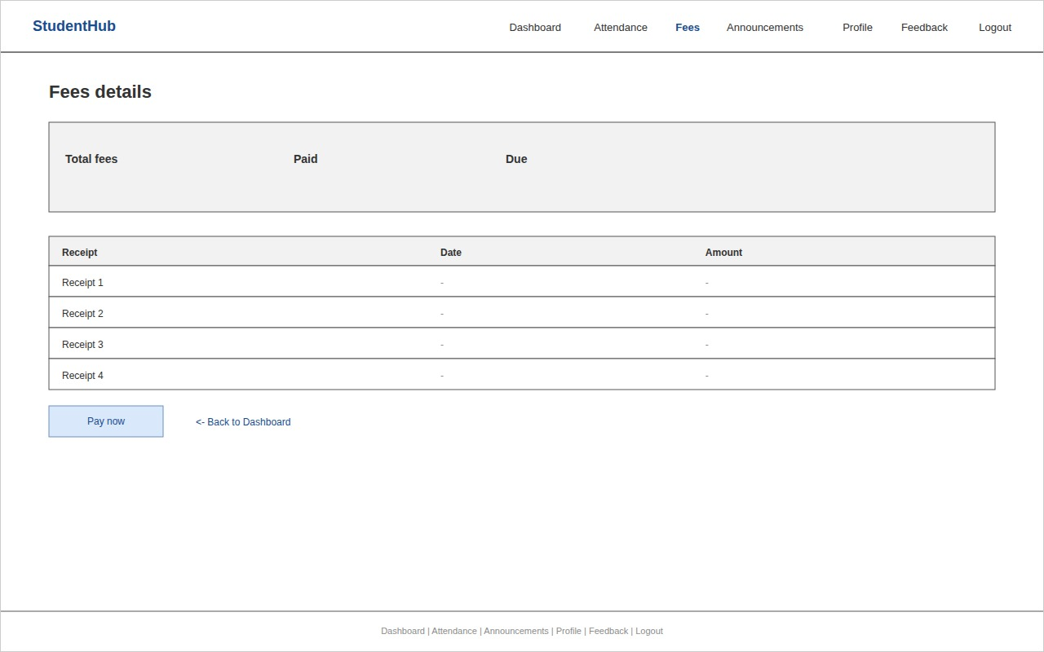

Announcements page :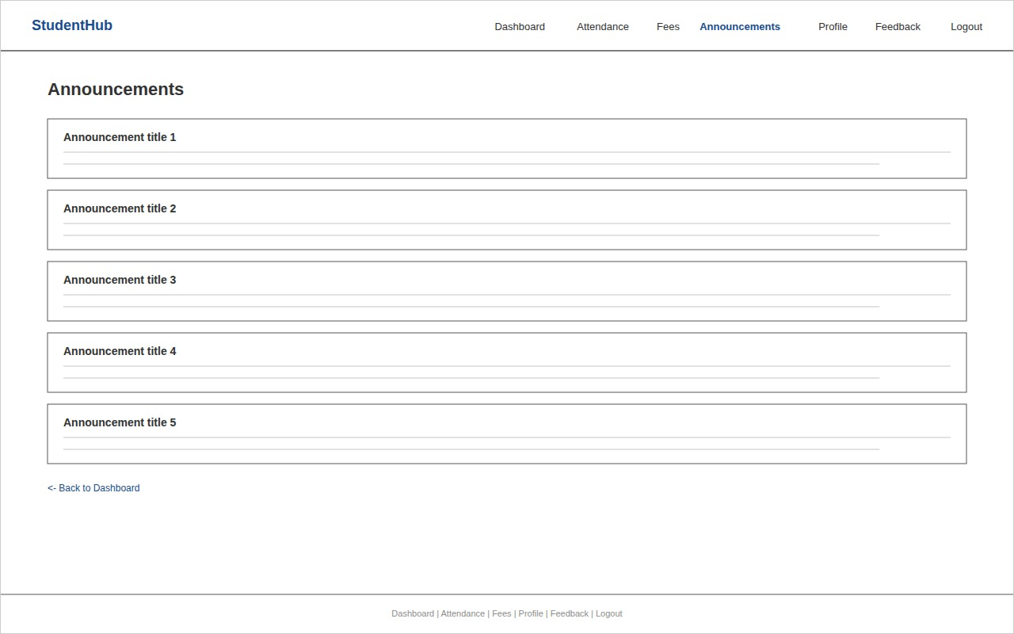
Profile page :
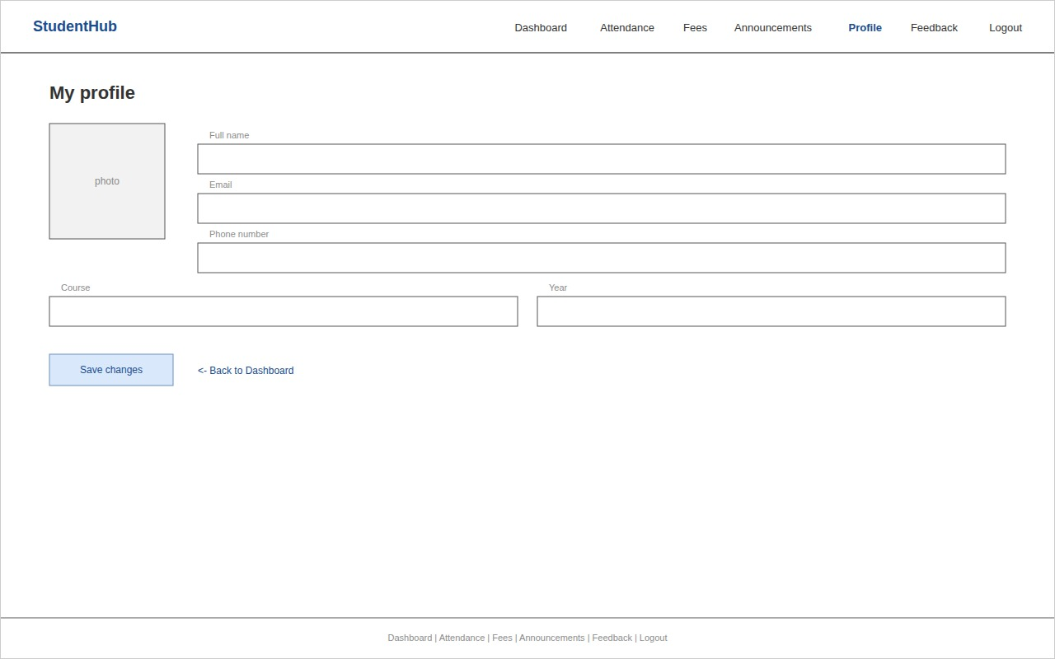

Feedback Page :
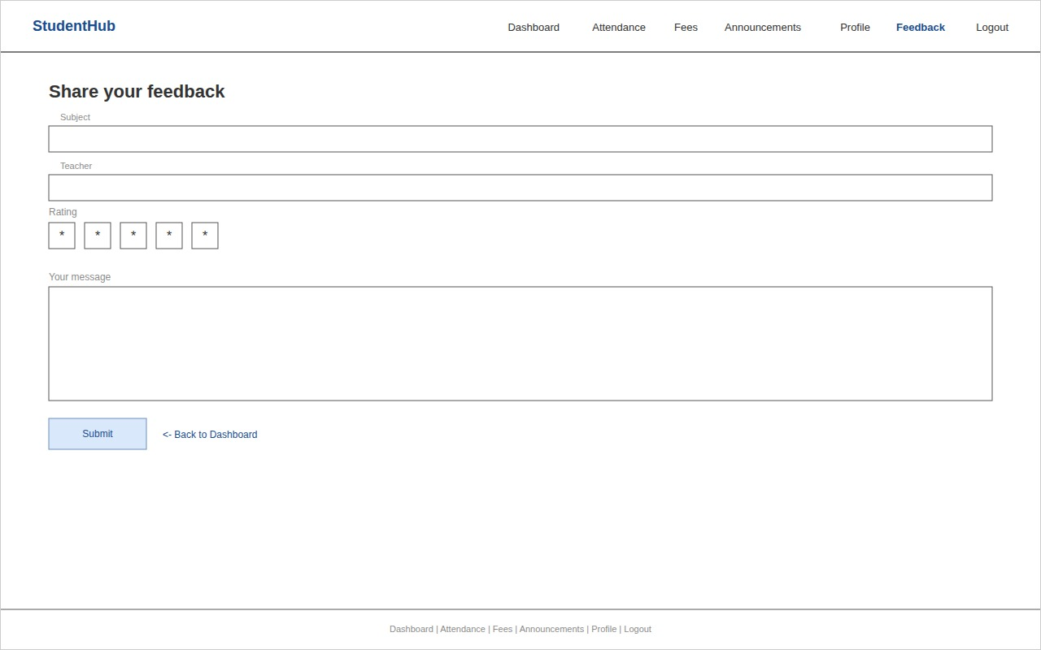

GitHub Repository Link:
https://github.com/kvvaghasiya49/Web_Development.git

Challenges Faced:
Deciding how many pages were really needed, and how they should connect without a confusing navigation, was the hardest part at first. Planning the sitemap on paper before making the wireframe helped organize this. Setting up Git for the first time and understanding the difference between git add, commit, and push also took a bit of trial and error.

Learning Outcomes:
Learned how to break a web application into pages and user roles before writing any code, and how a sitemap and wireframe save rework later. Also learned the basic Git/GitHub workflow (init, add, commit, push) that will be used throughout the semester.

Faculty Remarks:

